20MCA136 – NETWORKING & SYSTEM ADMINISTRATION LAB Dept. of Computer Applications

# NETWORKING & SYSTEM ADMINISTRATION LAB

**Name: MELBIN M P**

**Roll No: 19**

**Batch: S2 RMCA B Date: 05-05-2022**

**Experiment No: 10**

# Aim

Write a shell script to find largest of two numbers.

# Procedure

#!/bin/bash

echo "Enter the number1:" read n1

echo "Enter the number2:" read n2

if [ $n1 -gt $n2 ] then

echo "N1 is greater" else

echo "N2 is greater" fi

# Output

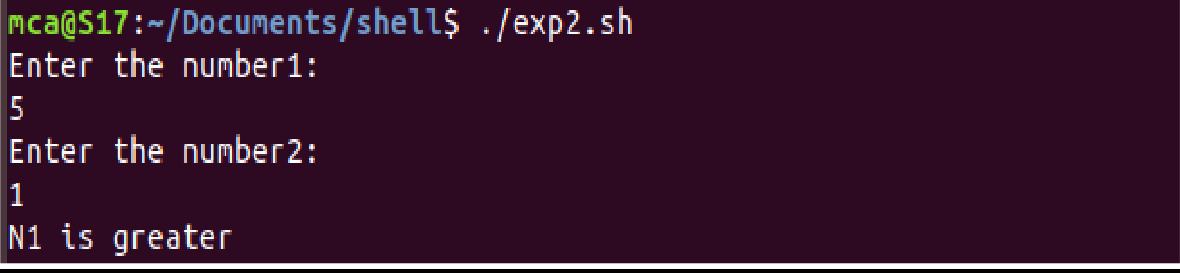

Amal Jyothi College of Engineering, Kanjirappally